GAM Design Findings - Ukraine
76% of Ukraine approved projects in the 2019 HPC completed the Gender with Age Marker, reflecting that the GAM was widely used in 2018 (74/97 total approved projects for Ukraine completed the GAM.)
GAM information summarized here demonstrates considerable attention to gender- and age-related issues in the project design phase.
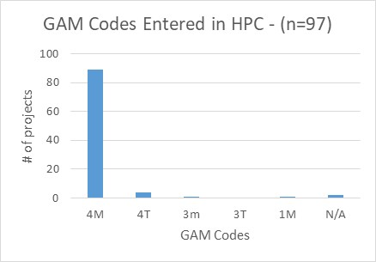
72 projects (97% of GAMs submitted) mainstream gender or gender AND age in their design (Codes 3 or 4.)
The GAM asks users to consider four program elements in project design: analysis, activities, participation and benefits. In ALL of these areas, at least 86% of projects show intention to address gender differences, and in most cases gender and age differences, in their projects.
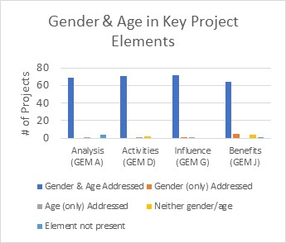
Under analysis, more than half of projects (57%) indicate a focus on “women, girls, boys, and men;” 11% are primarily concerned with women and children; 9% women and men, and only 3% with girls and boys only. We see that respondents are not just ticking all the boxes, as only 11 projects include the category “diverse gender identity.”
Excluding nine narratives not in English, approximately one third of projects (22) demonstrate clear analysis of effects of gender inequality and often also age inequalities in relation to their sector. Several organizations appear particularly strong in this respect. Another third (20 projects) express a desire to address inequality, as opposed to an analysis of it, or cite disaggregated statistics often unrelated to their sector or activities. Many projects focus their analysis exclusively on gender-based violence. Twenty projects (approx. 1/3) have no gender analysis.
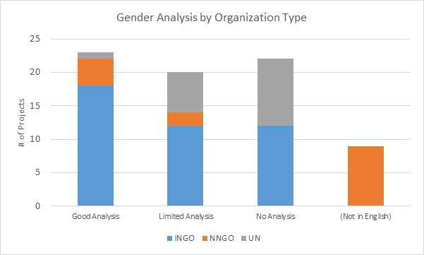
Support is needed to help project holders understand how and gender and age analysis can inform the activities to be delivered, how different groups can be engaged, or how results will be measured; and at sector level to ensure all partners understand the implications of marginalization for their work.
Half of projects plan to adapt or tailor activities on the basis of gendered needs, roles and dynamics. Slightly less tailor activities solely based on different needs. One project is a targeted action aiming to reduce gender barriers or discrimination.
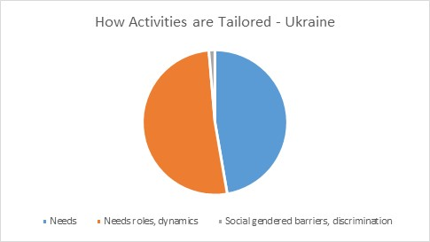
How affected people participate differs widely among projects and shows meaningful response. While 38% say affected people will be involved in all aspects of project management, most are more plausible. 30% of projects involve beneficiaries in three stages – assessment, design and delivery - with the remainder mostly selecting 1-2 aspects of project management where affected people will be involved. (see chart)
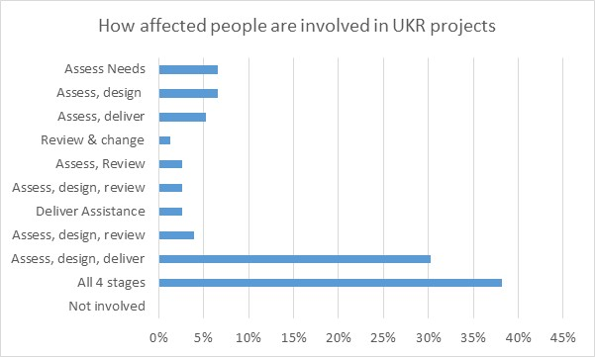
No doubt because of previous experience using the GAM, Ukraine has a high completion rate, and very few transcription errors when entering codes into HPC. There may still be a misperception that a “targeted action” (T) is somehow better than a project that mainstreams gender (M) as two projects changed their code from 4(M) to 4(T). Only one project “upgraded” their code from 0 to 4 when entering it in HPC.
In addition to highlighting overall strong performance in Ukraine, the GAM also identifies areas and agencies where programming can be more responsive to gender- and age-related exclusion. The September monitoring mission documented that many partners are using the tool to identify programming gaps and provide assistance in more inclusive and accountable ways, and that expertise exists in country to continue this process.
Use of the IASC Gender with Age Marker by humanitarian actors in Ukraine shows a shift toward delivering aid at new and higher standards. It is hoped that the organizational support required for its ongoing use in project and program monitoring will be continued.

