Design Results – Nigeria

Overview

25% (44/183) of Nigeria projects approved in the 2019 HPC applied the IASC Gender with Age Marker. Fourteen additional HPC accepted projects appear to have a valid GAM Reference number, but users likely failed to press “submit” on completion, as these forms are not found in the GAM database. Four organizations used the same GAM form for two projects (Terre des hommes, Jireh Doo Foundation, Grow Strong Foundation and ACF;) FAO and UNFPA also submitted the same GAM for two of their projects. 139 projects did not apply the GAM.
Compared to other countries, the GAM completion rate for Nigeria is low, but not surprising in the first year of use. Use by UNHCR is encouraging; all six UNHCR projects applied the GAM. Lack of use by other UN agencies is somewhat disappointing: only one UNICEF, and two WFP and FAO projects applied the GAM. Projects approved for IOM, OCHA, UN Women, UNDSS, UNMAS, UNFPA, UNDP and WHO did not use the GAM.
Sample GAM Completion Rates
 | South Sudan | Libya | Ukraine | Nigeria | Palestine | Somalia | Haiti
HPC Projects  Approved | 396 | 68 | 97 | 183 | 200 | 386 | 89
% with GAM | 19% | 75% | 76% | 25% | 79% | 25% | 19%

In this first year of use, it is important to continue to raise awareness of the purpose of the GAM.
The IASC Gender with Age Marker was designed in response to requests from the field for a tool that would help them understand HOW to do better gender equality programming. People knew they weren’t getting it right, but there was little practical advice on HOW projects could be improved.
The GAM offers 12 programming actions to improve attention to gender and age in projects and programs.
It is the process of discussing and answering the GAM questions about these programming actions that creates better projects (not the results that are achieved.) Ideally the GAM is used as a team planning or monitoring exercise.

Nigeria GAM information summarized here demonstrates considerable attention to gender- and age-related issues in the project design phase, among those project holders using the tool.
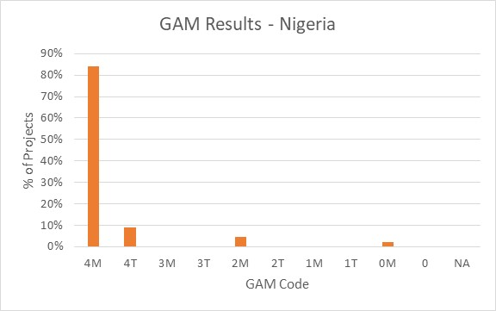
Of the 44 projects applying the GAM, 84% (37 projects) plan to respond to both gender and age differences (Code 4) throughout their program. Four projects are targeted actions (“T”) with a specific purpose to reduce inequality. There are only three projects that do not mainstream gender. No projects indicate that gender differences are not applicable (NA - they have no contact with or influence on services for affected people.)

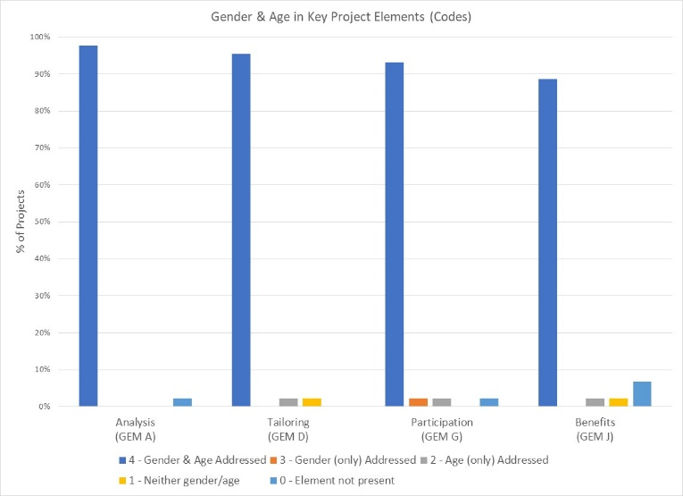

The GAM asks users to consider four program elements in project design: analysis, activities, participation and benefits.
In ALL of these areas, at least 89% of projects show intention to address gender and age differences in their projects.

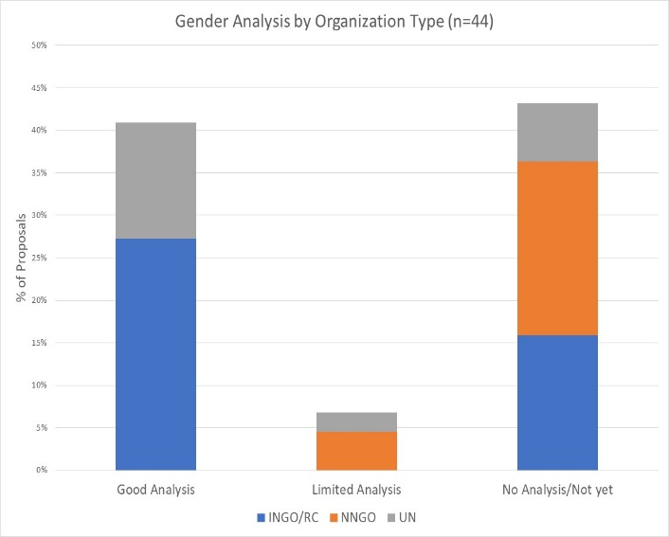
21/44 of Nigeria projects with GAM forms (48%) demonstrate a good analysis of gender and/or age inequality in Nigeria. An additional 9% (4 projects) have a limited concept of analysis, expressing an intention to address inequality as opposed to an analysis of it, or citing disaggregated statistics often unrelated to their sector or activities. Several projects focus their analysis almost exclusively on gender-based violence. Nineteen projects (43%) have no gender analysis. These projects may need support to understand how the marginalization of certain groups will impact on delivery of their services.

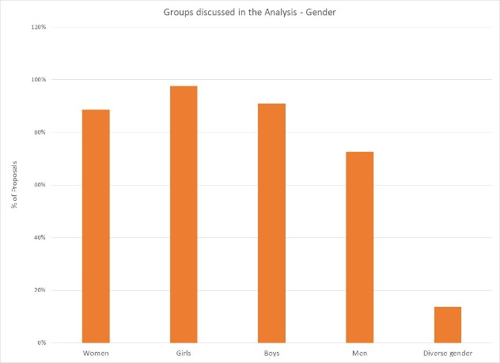
In their analysis, 66% of projects say they consider women and girls and boys and men. Overall, girls and boys are a focus of analysis in 98% and 91% of projects respectively, while 89% and 73% specifically include women and men. Six projects indicate that their analysis is concerned with people of diverse gender sexual orientation/ gender identity, but there is may be confusion about the definition as this gender group is not mentioned in the narrative analyses.

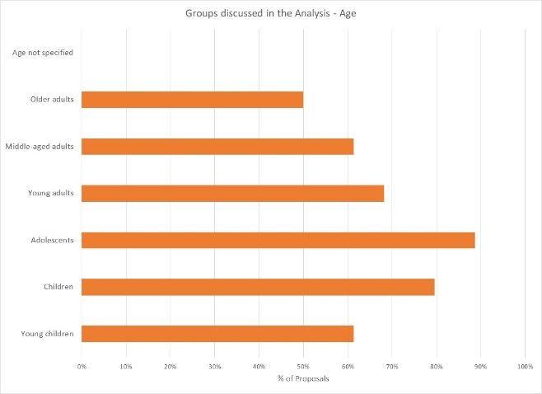
In contrast, only 30% of projects indicate their analysis includes all age groups; the majority are more selective. Adolescents and children are a focus of analysis in 89% and 80% of projects respectively. Only 50% of projects specifically consider the situation of older adults, and 61% with middle-aged adults and young children. All projects specify age groups in their analysis.

Support is needed to help project holders understand how and gender and age analysis can inform the activities to be delivered, how different groups can be engaged, or how results will be measured. Cluster coordinators can be involved to ensure partners share a common analysis of who is at risk and why, and that they understand the implications of this for their project activities.
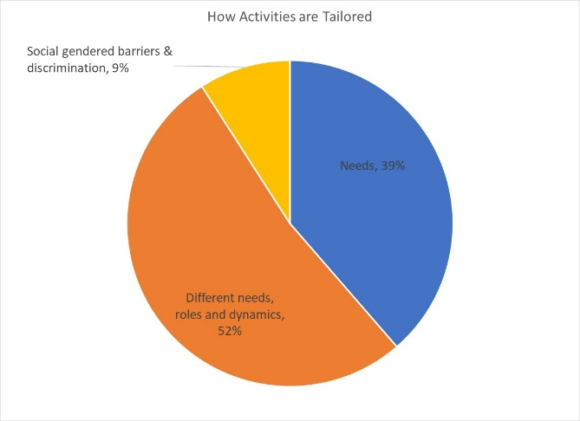
52% of projects plan to adapt or tailor their activities based on different gender-related needs, roles and dynamics, while 39% tailor activities based on the different needs. There are four projects that constitute “targeted actions” (Code T) to reduce gender barriers or discrimination; these are expected to be a small proportion of projects in humanitarian settings.

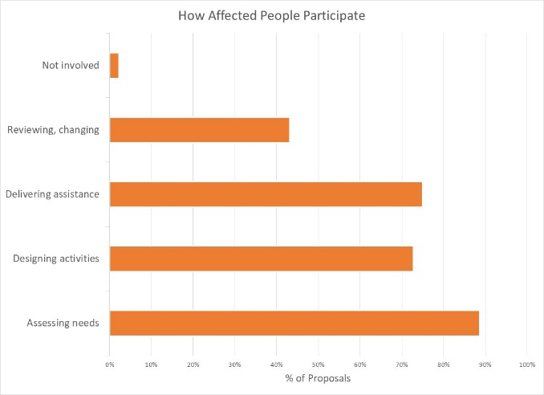
How affected people participate differs widely among projects and shows meaningful response. While thirteen projects say affected people will be involved in all aspects of project management, most are more realistic. The largest proportion of projects involve beneficiaries in assessing needs, followed by delivering assistance and designing activities. Only 43% of projects have beneficiaries involved in project review and revision. There is only one project where affected people will not be involved in any of these activities.

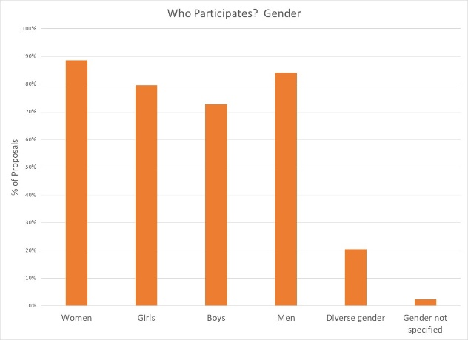

89% of projects intend to ensure women are involved in at least one aspect of project management; engagement of other gender groups is only slightly lower. 20% of projects indicate people of diverse gender/sexual orientation will be involved.

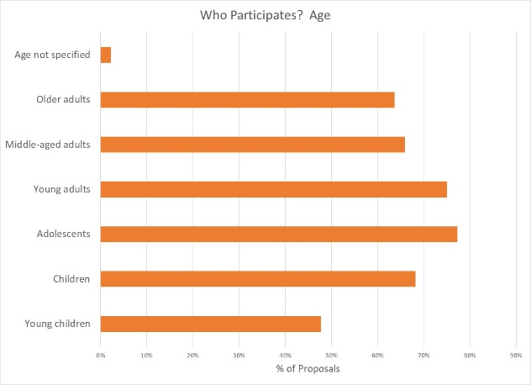
Participation by age groups reflects the concerns seen in the context analysis, with adolescents most engaged. Young adults are intended to be active, and over 64% of projects involving other age groups in project management, with the logical exception of young children.

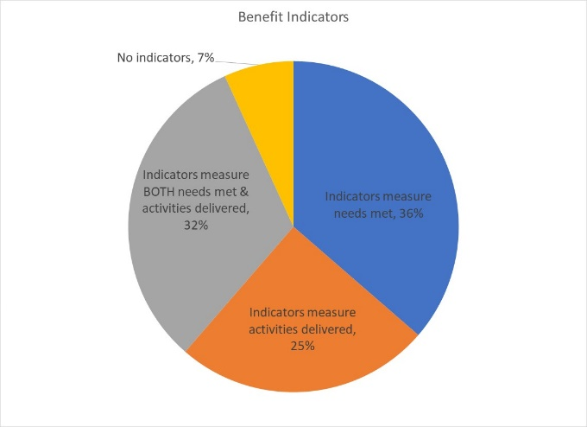
Reporting relative benefits
32% of projects say they will be able to provide disaggregated information on both the activities delivered, and the needs met. 36% of projects plan to report on needs and 25% on activities delivered, for different gender and age groups. Three projects report no indicators yet.

Summary
It will be important to ensure that HPC approved projects apply the GAM before beginning implementation. The GAM can be applied several times, as project holders decide to review and adjust their programs. Users report that the GAM has drawn their attention to gender- and age-related concerns that might otherwise have been missed.
A total of 48 GAM forms were completed for Nigeria, including 24 for projects that were not accepted in the HPC. There are 183 accepted projects in the HPC; the IASC Gender with Age Marker was completed for 44 (25%) of these. 14 additional accepted HPC projects cite a GAM reference but it appears that these users failed to actually “submit” the GAM form.
There seven “transcription errors” when copying GAM codes into the HPC. These show that there may still be a misperception that a “targeted action” (T) is somehow better than a project that mainstreams gender (M). Six projects changed their code from 4(M) to 4(T) when entering it in HPC tools; only one project ‘upgraded’ their code from 0 to 4(M). The analysis in this report is based on the correct GAM scores in the GAM data base.
It is commendable that the Gender with Age Marker was applied to 25% of projects in Nigeria, given the lack of formal direction from Agencies and few trained GAM resource people involved in-country.
In addition to highlighting overall strong desire to address specific needs of different groups – particularly adolescents in Nigeria, the GAM also identifies areas and agencies where programming can be more responsive to gender- and age-related exclusion. There may be a need to support some clusters and organizations in developing a socio-economic (gender) context analysis and understanding its relevance to how assistance is designed and delivered, but it is also clear that there is strong capacity for this among several actors in-country.
Use of the IASC Gender with Age Marker by humanitarian actors in Nigeria shows a shift toward delivering aid at new and higher standards. It is hoped that the support required for its ongoing use in project and program monitoring will be provided.
It is intended that ALL projects accepted in the HPC will apply the IASC Gender with Age Marker prior to starting implementation. Follow-up reports will be provided as more Nigeria actors complete their GAM forms.

