GAM Results:

Projects Addressing
Diverse Sexual Orientation
&
Gender Identity

Overview
Globally, 1340 out of ~8200 projects completing the GAM indicate that they are concerned with people of diverse sexual orientation and gender identity. 45 of these projects specifically mention LGBTI or transgender people in their narrative analysis; the remainder do not. This report reviews the Gender with Age Marker results for the 45 projects with explicit reference to SOGI.
All 45 GAM submissions addressing diverse SOGI are for the project design phase. Country and agency distribution is,
Country | # of Projects |  | Country | # of Projects
Argentina | 5 |  | Jordan | 2
BD | 5 |  | Lebanon | 1
Bolivia | 1 |  | Myanmar | 1
Brazil | 3 |  | Panama | 3
Chile | 2 |  | Peru | 1
Colombia | 2 |  | Paraguay | 1
Costa Rica | 1 |  | Serbia | 1
Dominican Republic | 1 |  | Syria | 1
Ecuador | 3 |  | Uruguay | 3
Iraq | 4 |  | Venezuela | 4

Organization | # of Projects | # Projects in LAC | Other countries
UNHCR | 16 | 10: (Brazil (3,) Chile, Colombia, Dominican Rep, Ecuador (2,) Panama, Uruguay | Bangladesh (3), Iraq (2), Serbia (1)
UNAIDS | 5 | 5: Argentina, Chile, Panama, Paraguay, Venezuela
INTERSOS | 3 | 1: Venezuela | Jordan (2)
IOM | 2 | 2: Argentina, Uruguay
Heartland | 2 | 0 | Iraq (2)
Other INGO | 4 | 3: Costa Rica, Ecuador, Bolivia | Myanmar
NNGO | 8 | 5: Argentina (3,) Peru, Venezuela | Bangladesh, Lebanon, Syria
Other UN | 5 | 4: Colombia, Panama, Uruguay, Venezuela | Bangladesh

GAM Results

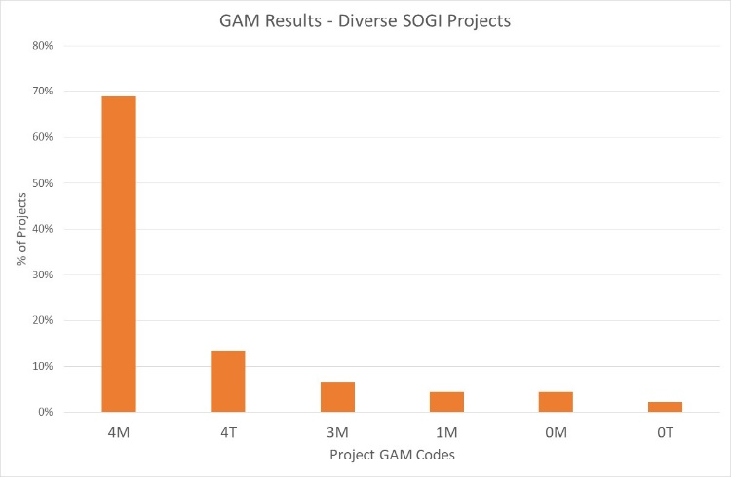
Of the 45 SOGI-inclusive projects applying the GAM, 82% (37 projects) plan to respond to both gender and age differences (Code 4), including six which are targeted actions (“T”) with the specific purpose to reduce inequality or discrimination. Three projects intend to address gender (but not age) differences, and five projects do not mainstream gender and/or age.

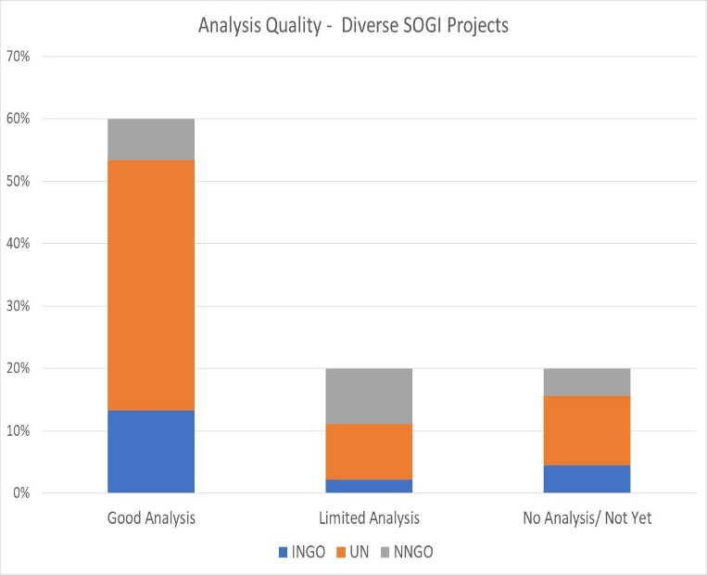
A quick scan of GAM submissions suggests that awareness of inequality and discrimination is higher than average for these projects. 60% of “SOGI-aware” projects (27) demonstrate a good analysis of gender and/or age inequality in context, compared to less than 50% of projects in most appeals. The quality of analysis is determined by Column Y of the GAM data, where project holders are asked to describe their gender analysis. Based on rapid review, projects that clearly describe or provide an example of role and/or power differences (“gender analysis”) are coded green. 20% of SOGI projects appear to have limited, and 20% no gender analysis yet (yellow and red - 9 projects each.) These projects most often describe a policy or express a commitment to address inequality rather than an example of actual differences in the context. This reflects a common misunderstanding of tool: its purpose is not to persuade others of the value of a project, but rather an opportunity for project holders to articulate and confirm the relevance and coherence of their program actions.

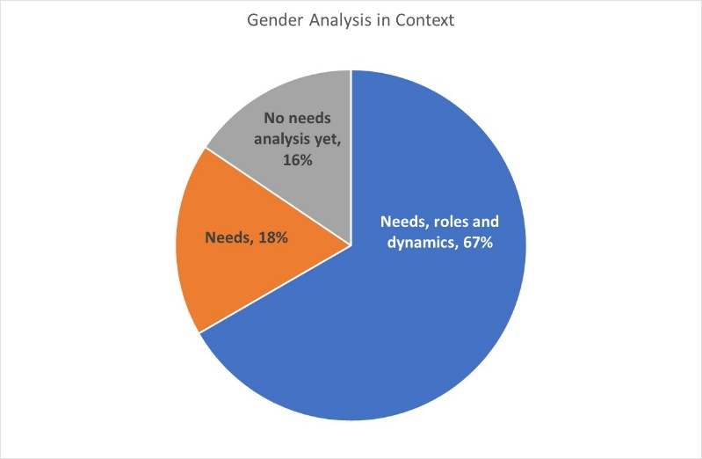
A higher proportion of these projects base their analysis on needs, roles and social dynamics (67%) compared to humanitarian projects in general, where 50% or less consider roles and dynamics in their analysis.

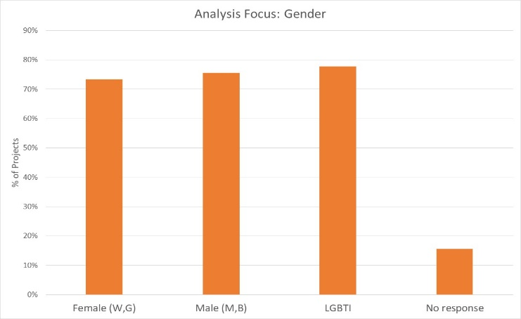

69% of projects include people of all gender (F, M, D),in their analysis, and 78% confirm that they are concerned with people of diverse gender sexual orientation/ gender identity (LGBTI).

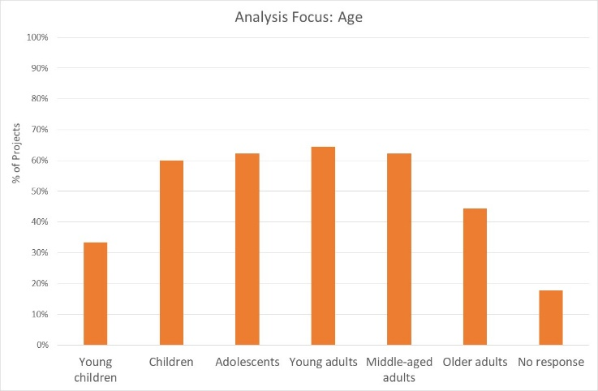
Approximately 60% of projects are focused on one or more age groups from children to adults. Young children are a focus for analysis in only 30% projects, and older adults in only 44% of projects. While the former might be expected, the low participation of older people may be an area for further enquiry.

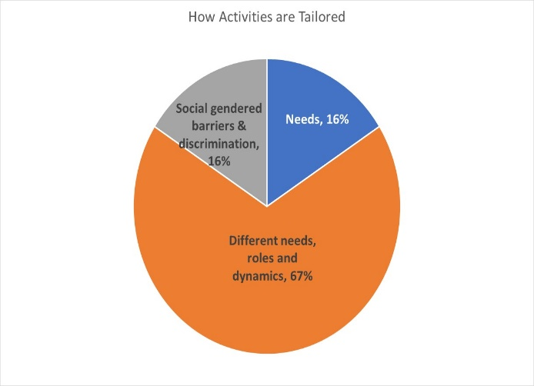
Projects concerned with people of diverse SOGI projects are also atypical of standard humanitarian projects in how they tailor activities.
Like the analyses, nearly 70% of these projects tailor activities based on different needs, roles and social dynamics, and only 16% according to needs alone. In other samples, this proportion is usually closer to 50-50.
Seven out of 45 projects (16%) constitute “targeted actions” (Code T) with activities designed to reduce gender barriers or discrimination. This is a notable difference from most humanitarian settings where targeted actions typically constitute less than 5% of humanitarian response projects.
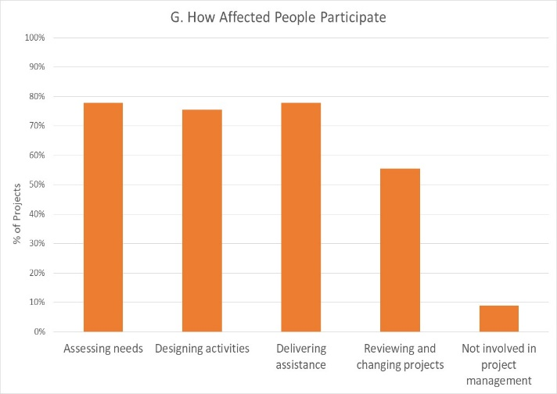
How affected people are expected to participate differs among projects. Almost half of all projects (22) say affected people will influence all stages of project management, and 18% have affected people involved in 3 out of the 4 areas, excluding project review and revision. The remainder say beneficiaries will influence one or two of these areas. There are only 4 projects where affected people will not be involved in any of these activities. It is interesting that the area where beneficiaries are expected to participate least is in reviewing and changing projects.
71% of projects intend that all gender groups - female, males, and LGBTI/diverse SOGI – will participate in and influence the project. 84% of all projects are planning for people of diverse gender/sexual orientation (LGBTI) to influence project management. Three projects indicate that only LGBTI people will be involved (UNHCR - 2, and UNAIDS – 1.)
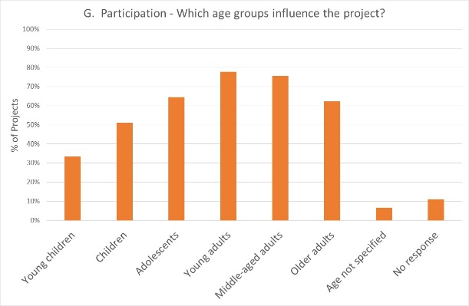
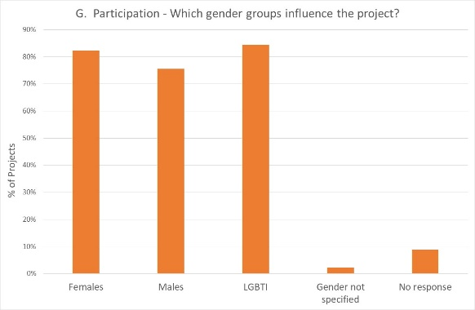
Participation by age groups reflects an overall trend seen in larger sample sizes: while children will be logically the least involved, only about 60% of project plan to involve adolescents and/or older adults. This may be a topic for further discussion.

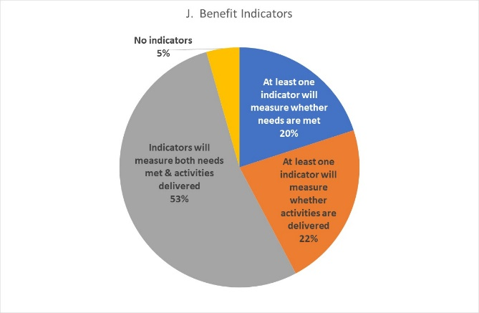
Reporting relative benefits

Of the 45 S0GI-sensitive projects using the GAM for project design, more than half say they will be able to provide disaggregated information on both the activities delivered, and the needs met. 84% of projects will provide results disaggregated by sex, including 52% planning to disaggregate results for one or more age groups.

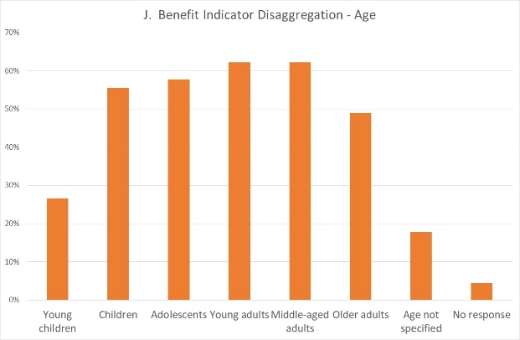
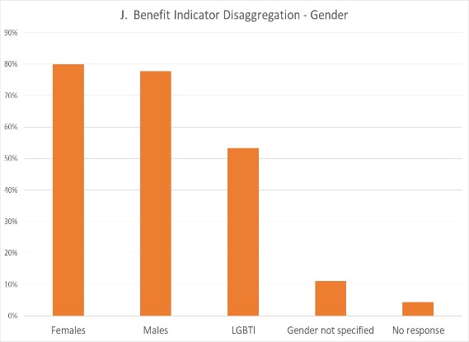

Conclusion
The IASC Gender with Age Marker currently only looks at gender and age differences, but the next version of the questionnaire (also shorter!) will integrate questions on the response for people with disabilities.
This overview of projects addressing needs of people with diverse sexual orientation and/or gender identity suggests higher than average awareness of the implications and relevance of gender differences for humanitarian response. Opportunities for peer learning within clusters and countries should be considered, particularly how the gender analysis forms the logical basis for subsequent actions, including how activities are tailored for different groups, how different people will participate, and how different benefits will be measured. There are clearly some agencies that stand out as attempting to deliver programs genuinely responsive to people of diverse genders..
Use of the GAM for monitoring these projects will provide valuable information on how a variety of accountability and protection actions are meeting the needs of people of diverse genders. Monitoring should be encouraged once project have been under implementation for 3-4 months.

16 March 2020

