GAM Results:
Nigeria FTS Projects

Overview
There are 184 projects in the Nigeria 2019 FTS; 49 of these have a valid GAM reference number, however five organizations (Terre des Hommes, Jireh Doo, Grow Strong, ACF, FAO) submitted the same GAM for two projects, leaving 44 projects (24%) with a completed GAM.
A total of 241 projects in Nigeria have completed the IASC Gender with Age Marker. 44 of these are found in FTS. 39 have used it for project design, and 5 for project monitoring; none of these projects claim gender is “not applicable.”
There were 9 transcription errors in copying the GAM Code into FTS:
- seven projects changed the project focus from M to T (Street Child (2), Plan (2), UNHCR, Grow Strong, Centre for Social Change
- one project changed the focus from T to M (Street Child), and one project “upgraded” the numeric code from 0 to 4 (Mercy Corps.)
The design phase of the GAM asks users to consider four essential programming actions that contribute towards gender and age inclusion: analysis, tailoring of activities, participation, and benefits. The monitoring phase asks users to report on these four, plus eight additional indicators.
Design & Monitoring | Monitoring Only
- Analysis | - Data Disaggregation | - Targeting
- Tailoring of Activities | E. Gender-based Violence | F. Coordination
G. Influence (Participation) | H. Feedback & Complaints | I. Communication (Transparency)
J. Benefits | K. Satisfaction | L. Project Problems

In this first year of use, it is important to continue to raise awareness of the purpose of the GAM.
The IASC Gender with Age Marker was designed in response to requests from the field for a tool that would help humanitarians understand HOW to do better gender equality programming. People knew they weren’t getting it right, but there was little practical advice on HOW projects could be improved.
The GAM can be described as a “learning by doing” tool, based on the premise that systematically thinking about and responding the questionnaire will result in more inclusive and responsive projects. It is the process of discussing and answering GAM questions about the twelve programming actions that creates better projects - not the results that are achieved. Ideally the GAM is used as a team planning or monitoring exercise.
Nigeria GAM information summarized here demonstrates considerable attention to gender- and age-related issues, as well as several questions for further reflection and discussion among project holders using the tool.

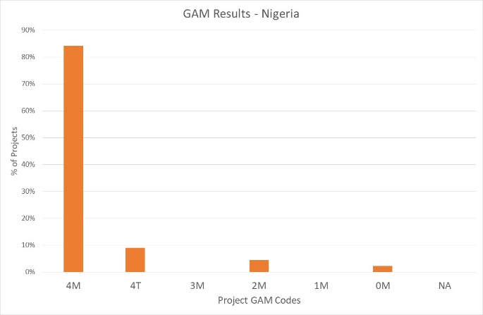
Of the 44 Nigeria FTS projects applying the GAM, 84% (37 projects) plan to respond to both gender and age differences (Code 4), including four that are targeted actions (“T”) with the specific purpose to reduce inequality; two projects (18%) intend to address age (but not gender) differences. There is one project that does not mainstream gender and/or age.

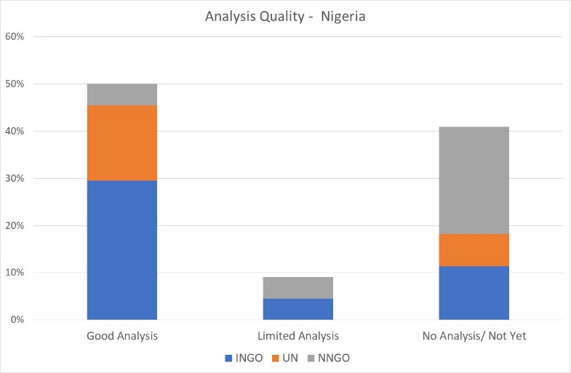
A very cursory scan of GAM submissions suggests that 50% of Nigeria projects (22) demonstrate a good analysis of gender and/or age inequality in context. This is determined by Column Y of the Nigeria GAM data, where project holders are asked to describe their gender analysis. Based on rapid review, projects that clearly describe or provide an example of role and/or power differences (“gender analysis”) are coded green. 9% of Nigeria projects appear to have limited (yellow – 4 projects) and 41% have no analysis yet (red-18 projects.) These projects most often describe a policy or express an intention or commitment to address inequality rather than an analysis of actual differences in the context. This reflects a common misunderstanding of tool: its purpose is not to persuade others of the value of a project, but rather an opportunity for project holders to articulate and confirm the relevance and coherence of their program actions. Projects lacking gender analysis may need support to understand how the marginalization of certain groups will impact on delivery of their services.
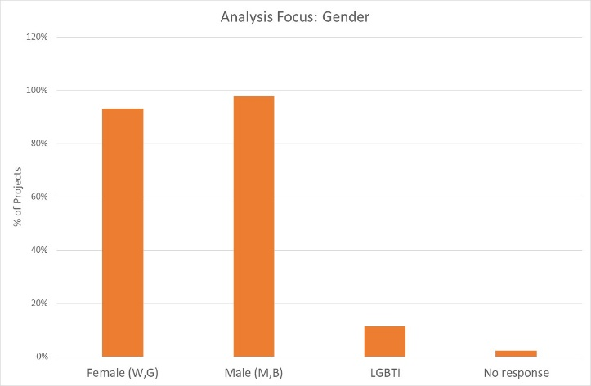
82% of projects say their analysis considers both females and males. Separately, 93% of projects consider females, and 98% males. 5 projects (11%) indicate their analysis is concerned with people of diverse gender sexual orientation/ gender identity (LGBTI), but this likely reflects misunderstanding of the terms as this group is not mentioned in any of the project narratives.

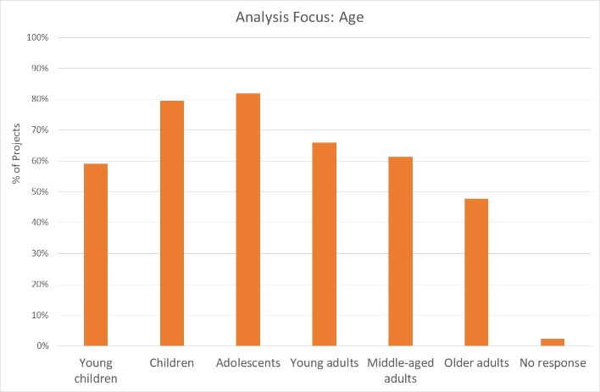
25% (11 projects) indicate their analysis is concerned with all age groups; others are more selective. 80% and 82% of projects are concerned with children and adolescents respectively, followed by young and middles-aged adults and young children. Older adults are a focus of analysis in only 48% of projects. It should be noted however, that issues affecting the prioritized gender and age groups are not always reflected in the analysis.
Support may be needed to help project holders understand how and gender and age analysis can inform the activities to be delivered, how different groups can be engaged, or how results will be measured. OCHA and cluster management can be involved to ensure project teams share a common analysis of who is at risk and why, and that they understand the implications of this for their project activities.
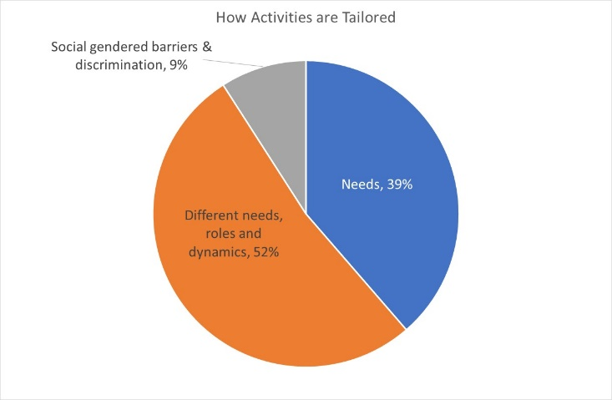
Slightly more than half of Nigeria projects are adapt their activities according to the different needs, roles and dynamics of different groups, while 39% tailor activities based solely on needs. Five projects are “targeted actions” (Code T) with activities designed to reduce gender barriers or discrimination; Nigeria has a higher than average proportion of such projects for humanitarian settings.

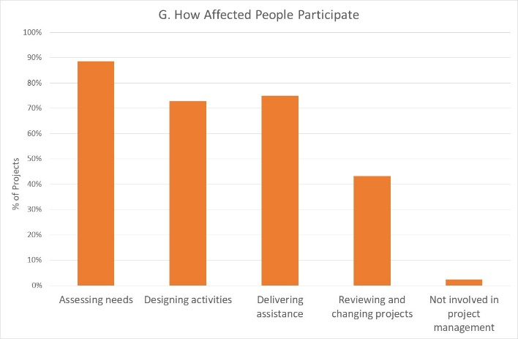
How affected people participate differs among projects. 30% of projects say affected people influence all stages of project management, and 27% have affected people involved in 3 out of the 4 areas, excluding project review and revision. The remainder say beneficiaries influence one or two of these areas. There are only one project where affected people will not be involved in any of these activities. It is interesting that the area where beneficiaries are expected to participate least is in reviewing and changing projects.

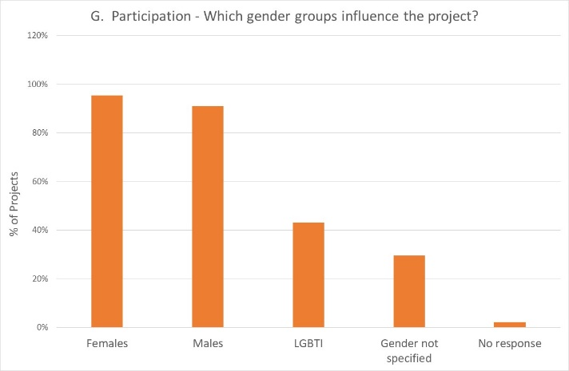
Participation of females and males is intended to be fairly equal in Nigeria projects. 19 projects (43%) indicate that people of diverse gender/sexual orientation (LGBTI) will be involved, again suggesting possible misunderstanding of this gender catergory.

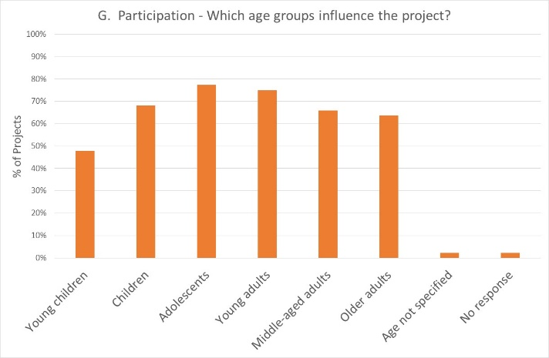
Participation by age groups is intended to be quite inclusive and diverse. While young children are logically the least involved, the slightly lower participation rate of older adults is also typical of humanitarian setting. Nigeria has notably higher engagement of adolescents than many countries.

Reporting relative benefits
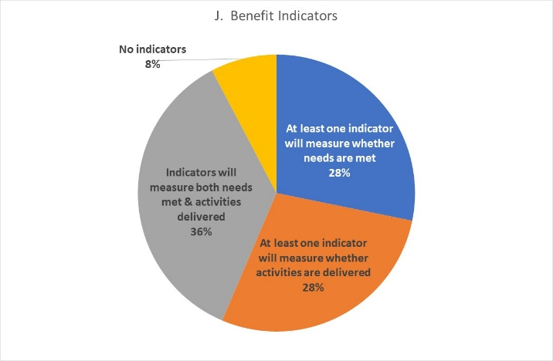
Of the 39 projects using the GAM for project design, projects are roughly equal on the information they plan to report. 36% say they will be able to provide disaggregated information on both the activities delivered, and the needs met. 28% intend to report on whether needs are met, and 28% will report on whether the activities are delivered. 85% of projects will provide results disaggregated by sex, and 60% will disaggregate results for one or more age groups.

Project Monitoring
The five Nigeria projects that have used the GAM for monitoring represent a very small sample but still serves to demonstrate the utility of the GAM, particularly its ability to describe accountability and protection in the monitoring phase, including for specific gender and age groups. A brief quick look at their results gives an indication of the type of information that will be available from this.

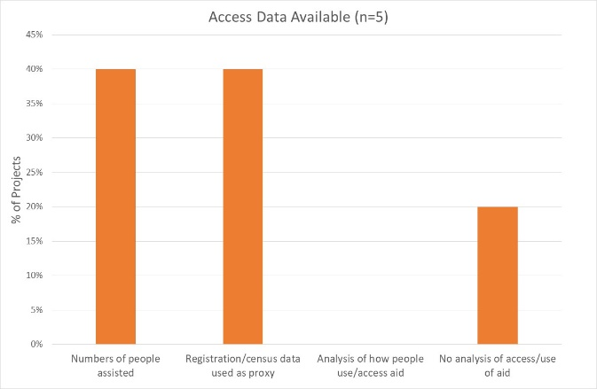
Access to Assistance: Only two out of five projects report data on actual numbers of people assisted; two rely on registration or population estimates. One reports no analysis of how people access or use the aid. However, 4/5 projects indicate data is disaggregated by sex for one or more age groups.

Targeting: All five projects report that people access aid as planned. However, when asked specifically about gender and age groups who might be missing out, two projects then say that males are missing out or getting less than planned, and one indicates that females miss out because of barriers. Two projects report that young children, children and adolescents may be missing out.
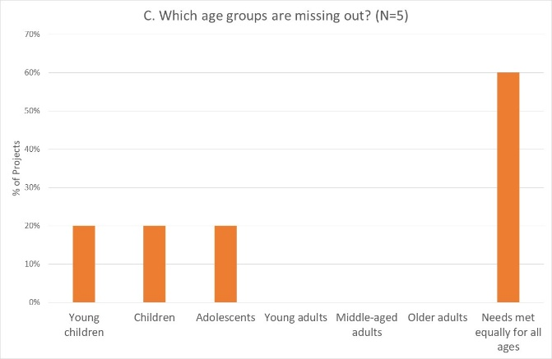
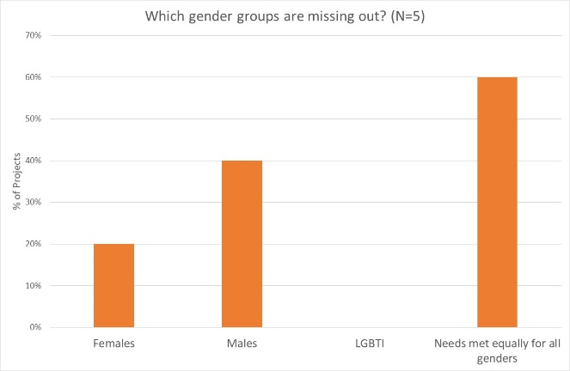

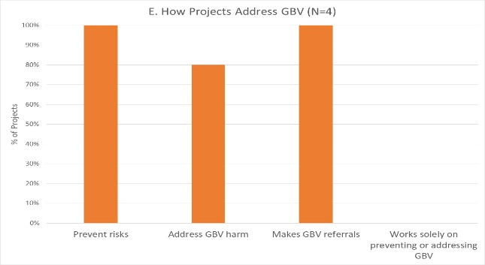
Gender-based violence: All five projects report working to prevent risk of GBV, and also to make referrals. Four out of five projects directly address GBV harm. This is consistent with project narratives in which GBV is clearly a priority for many projects. There still appears to be confusion about LGBTI/diverse SOGI (this is never mentioned in narrative), but information about GBV in relation to age groups of concern is clear and plausible.
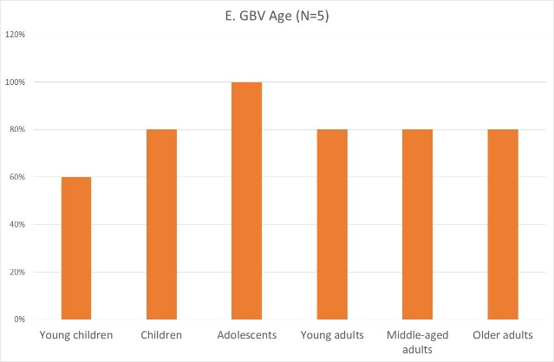
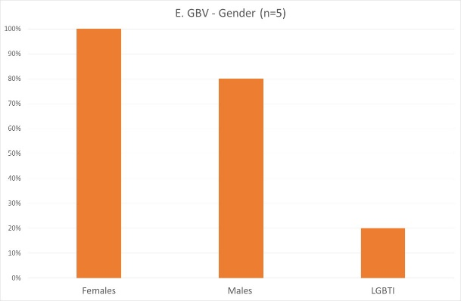

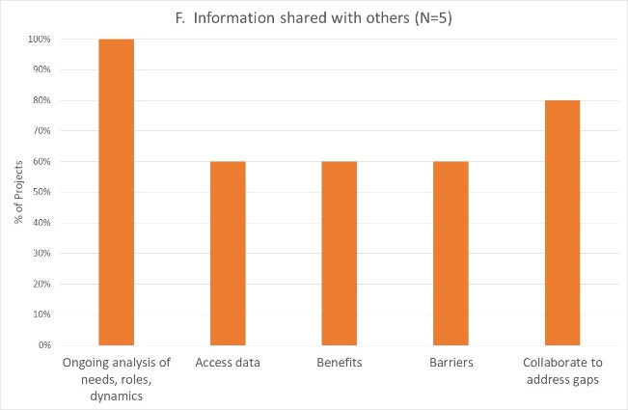
Coordination: All 5 projects reports coordinating and sharing a variety of information with others in the cluster. All projects report that shared information is disaggregated by both sex and age.

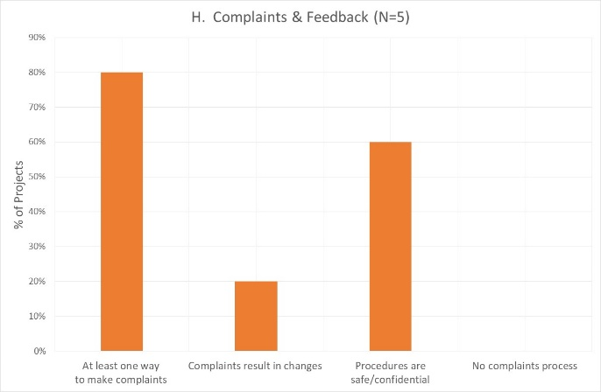
Complaints and Feedback mechanisms: All five projects report having a complaints mechanism in the monitoring phase. Three out of five indicate that it is safe and confidential, though only one indicates that complaints result in changes.
Three projects indicate procedures are the same for all gender groups, while two say there are different procedures based on gender and/or age.

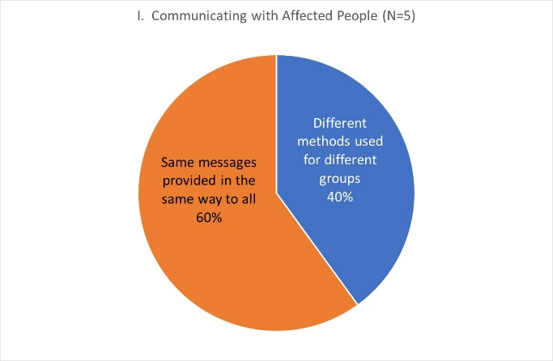
Communication with Communities/Transparency:
Two of the five Nigeria projects tailor their communication about project services to reach different gender or age groups, while three projects provide the same messages to all.

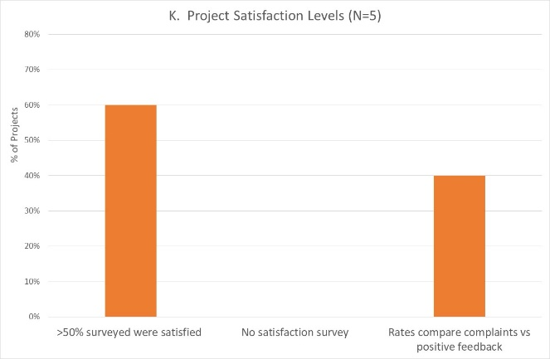
Satisfaction:
Three out of five projects found more than 50% of those surveyed weresatisfied with the assistance and the way it was delivered; two projects assess satisfaction by comparison with complaints received.

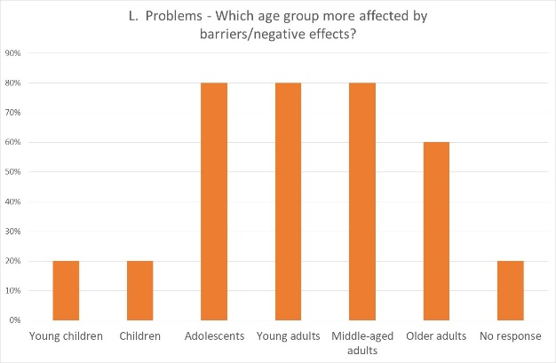
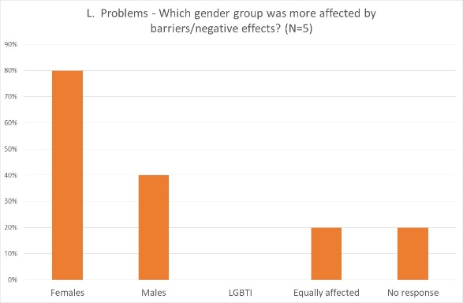
Dealing with negative effects: Three out of five projects have documented unexpected problems or barriers, and three projects have strategies planned or in place. Only one project reports no problems identified. Females tended to be more affected than males, and adolescents/adults more affected than children.

Conclusion
The IASC Gender with Age Marker currently only looks at gender and age differences, but the next version of the questionnaire (while shorter!) will also integrate people with disability.
While this overview of GAM use in Nigeria demonstrates its potential for supporting projects to provide relevant and responsive assistance for different groups, please view the data with caution. There is some evidence that the questionnaire is not always understood or taken seriously, e.g. the responses for LGBTI. Accuracy of responses will improve with growing organizational and management interest in the results. Even this limited sample provides evidence and examples of what projects are doing well, where good programming capacity exists, and where support can be provided.
An excellent starting point for gender advisors and focal points might be be Column Y of the database (Worksheet ‘Nigeria’), where organizations apparently unable to articulate a simple gender analysis can be assisted to understand how this is fundamental to designing and implementing a gender-responsive project.

12 March 2020

