GAM Results:
Venezuela

Overview
A total of 228 projects in Venezuela have completed the IASC Gender with Age Marker. 223 have used it for project design, and two for project monitoring, though it appears theses may have completed the monitoring form in error. Three projects claim gender is “not applicable” to their activities: OCHA, ACTED, Fundación S4V. These results cover all GAM submissions to date and are not for a specific appeal or year. Results can be correlated and compiled for a particular appeal if the project submission document requested applicants to provide the GAM reference number.
Projects can complete the GAM at any time, and those accepted for an appeal should do so before they begin implementing their activities.
The design phase of the GAM asks users to consider four essential programming actions that contribute towards gender and age inclusion: analysis, tailoring of activities, participation, and benefits. The monitoring phase asks users to report on these four, plus eight additional indicators.
Design & Monitoring | Monitoring Only
- Analysis | - Data Disaggregation | - Targeting
- Tailoring of Activities | E. Gender-based Violence | F. Coordination
G. Influence (Participation) | H. Feedback & Complaints | I. Communication (Transparency)
J. Benefits | K. Satisfaction | L. Project Problems

In this first year of use, it is important to continue to raise awareness of the purpose of the GAM.
The IASC Gender with Age Marker was designed in response to requests from the field for a tool that would help humanitarians understand HOW to do better gender equality programming. People knew they weren’t getting it right, but there was little practical advice on HOW projects could be improved.
The GAM is a “dual purpose” tool: in the design phase, its purpose is reflective learning. The design questionnaire steps users through the things they need to think about in order to develop a gender- and age-responsive program. The responses don’t tell us what is actually delivered, and are most appropriately viewed as “promises and good intentions.”
In the monitoring phase it performs the same function but more importantly, GAM results provide a unique overview of humanitarian performance - globally, by country, or by organization - for how gender and age differences are actually being addressed across a range of accountability and protection indicators.
GAM results cannot be used to screen or assess projects as the code is NOT a reflection of program quality. The aim is to increase the proportion of projects applying the GAM, based on the premise that systematically thinking about and responding to the questionnaire results in more inclusive and responsive projects: the 2020 target is for 80% of IASC projects to apply the GAM.
Venezuela GAM information summarized here demonstrates considerable attention to gender- and age-related issues, as well as several questions for further reflection and discussion among project holders using the tool.
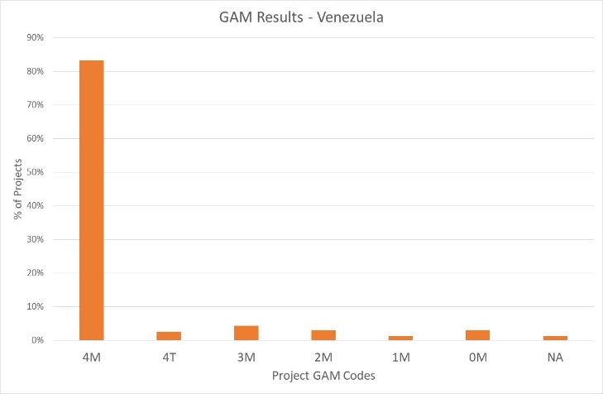
Of the 228 Venezuela projects applying the GAM, 86% (196 projects) plan to respond to both gender and age differences (Code 4), including six that are targeted actions (“T”) with the specific purpose to reduce inequality. 12 projects (5%) intend to address gender (but not age) differences, including two targeted actions. There are twenty projects that do not mainstream gender and/or age.

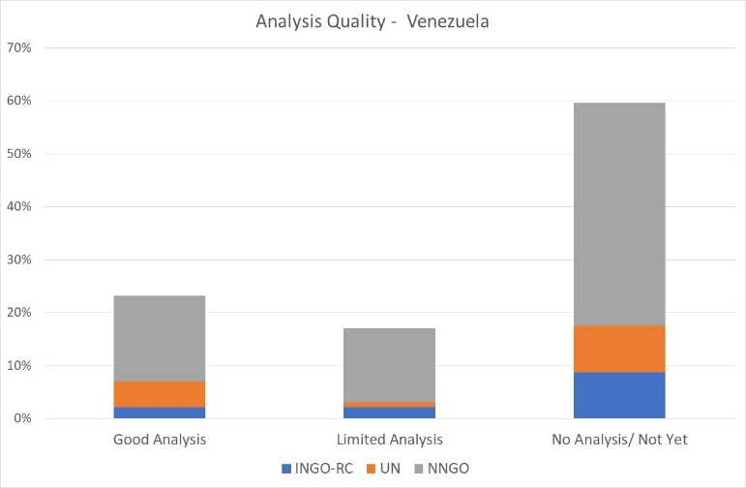
A very cursory scan of GAM submissions suggests only about 23% of Venezuela projects (53) demonstrate a good analysis of gender and/or age inequality in context. This is determined by Column Y of the Venezuela GAM data (“VZ”), where project holders are asked to describe their gender analysis. Based on rapid review, projects that describe or provide an example of role and/or power differences (“gender analysis”) are coded green. 17% of Venezuela projects appear to have limited (yellow - 39 projects) or no gender analysis (red-136, 60%.) Many of these reasonable say, “not yet.” More often though these projects describe a policy or approach or their commitment to address inequality, rather than demonstrate their understanding of inequality in the context. This reflects a common misunderstanding of tool: its purpose is not to persuade others of the value of a project, but rather an opportunity for project holders to articulate and confirm the relevance and coherence of their program actions. Projects lacking gender analysis may need support to understand how the marginalization of certain groups will impact on delivery of their services.
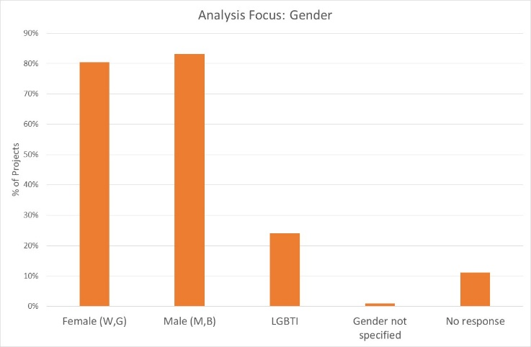
54% of projects say their analysis considers both females and males. Separately, 80% of projects consider females, and 83% males. 54 projects (24%) indicate their analysis is concerned with people of diverse gender sexual orientation/ gender identity (LGBTI).

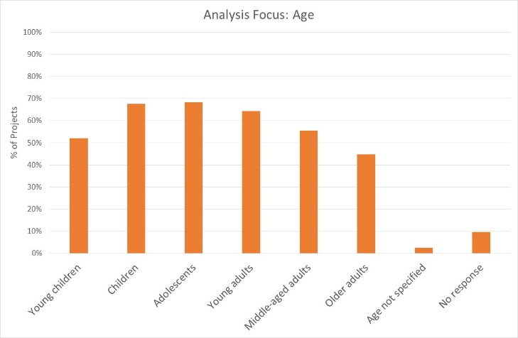
26% (58 projects) indicate their analysis is concerned with all age groups; others are more selective. The age groups of greatest concern are children and adolescents (68% of projects). Older adults are a focus of analysis in only 45% of projects. It should be noted however, that issues affecting the prioritized gender and age groups are not always reflected in the analysis.
Support may be needed to help project holders understand how and gender and age analysis can inform the activities to be delivered, how different groups can be engaged, or how results will be measured. OCHA and cluster management can be involved to ensure project teams share a common analysis of who is at risk and why, and that they understand the implications of this for their project activities.
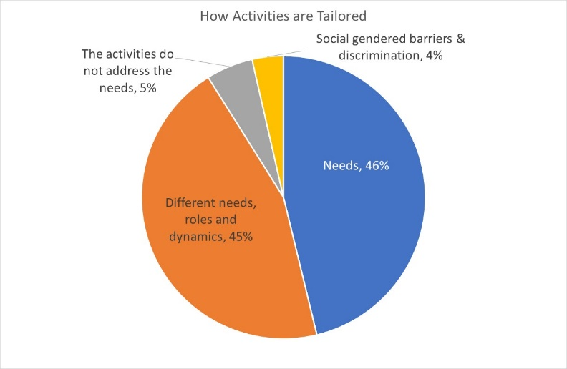
Venezuela projects are equally divided according to whether they will tailor activities based solely on needs, or adapt activities according to the different needs, roles and dynamics of different groups. Eight projects will be “targeted actions” (Code T) with activities designed to reduce gender barriers or discrimination; these are normally a very small proportion of projects in humanitarian settings.

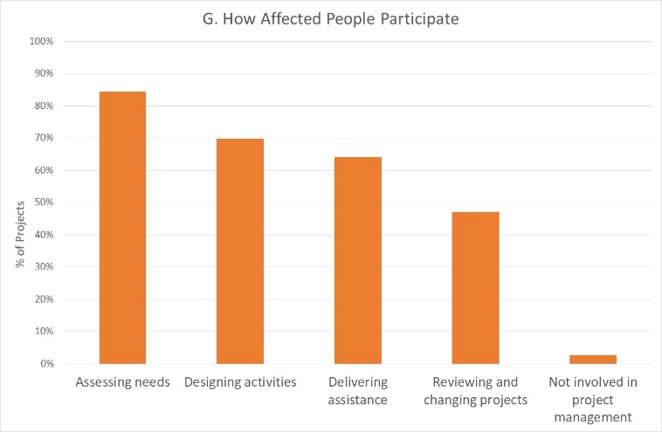
How affected people will participate differs among projects. 32% of projects say affected people will influence all stages of project management, and 17% have affected people involved in 3 out of the 4 areas, excluding project review and revision. The remainder intend for beneficiaries influence one or two of these areas. There are only 6 projects where affected people will not be involved in any of these activities. It is interesting that the area where beneficiaries are expected to participate least is in reviewing and changing projects.

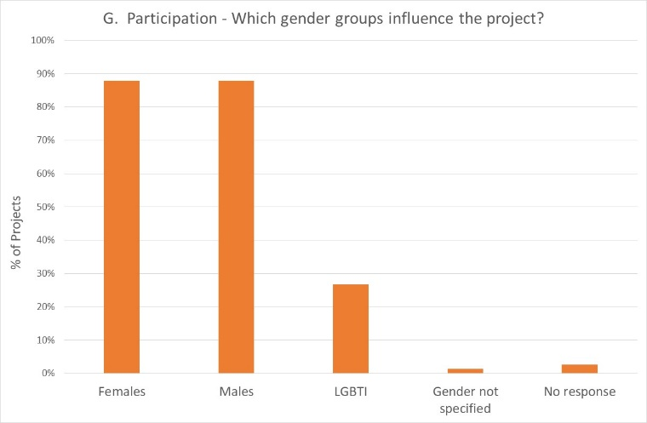
Females and males are intended to participate equally in Venezuela projects; 60 projects (27%) indicate that people of diverse gender/sexual orientation (LGBTI) will be involved.

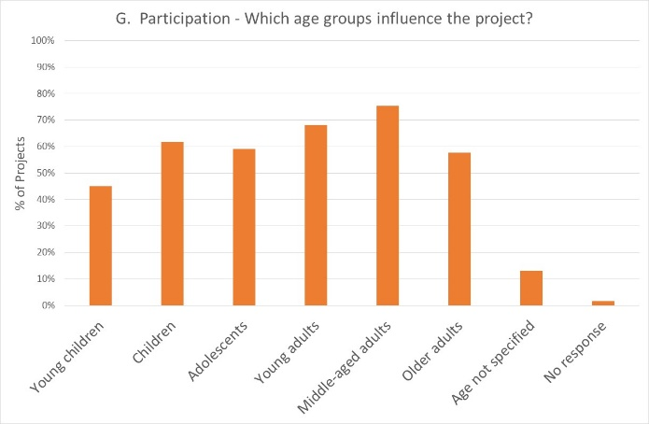
Intended participation by age groups reflects an overall trend seen in much larger sample sizes: while young children are logically the least involved, the lower participation rates of adolescents and older adults is a potential concern. However, Venezuela has notably higher engagement of children than many countries.

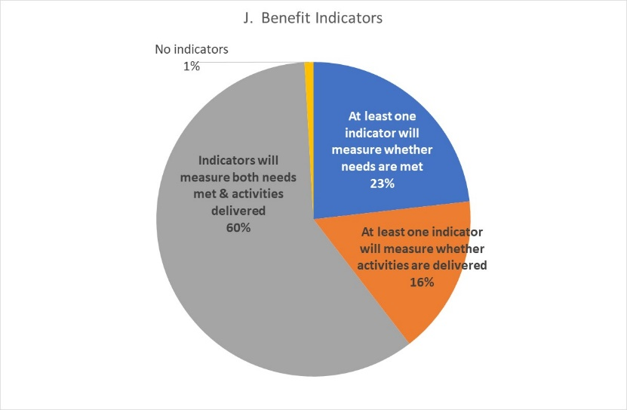
Reporting relative benefits
Of the 223 projects using the GAM for project design, 59% say they will be able to provide disaggregated information on both the activities delivered, and the needs met. 95% of projects will provide results disaggregated by sex, and over 70% of projects say they will disaggregate results for one or more age groups.

Project Monitoring
Only two Venezuela projects have completed the GAM for monitoring, and these appear to be in error. However, the charts are still included in the excel workbook, to demonstrate the kind of information that will become available as monitoring is carried out. Information will be available on gender and age differences in,
- Actual access to assistance
- Which groups appear to be missing out
- GBV integration
- Type of information shared in clusters
- Feedback and complaints mechanisms
- Communication with communities
- Satisfaction
- Project problems and barriers encountered
Projects should be reminded to complete the GAM for monitoring once projects have been under implementation for a few months.

Conclusion
The IASC Gender with Age Marker currently only looks at gender and age differences, but the next version of the questionnaire (while shorter!) will also integrate people with disability.
The quality of GAM information will continue to improve with growing organizational and management interest in the results. Managers are encouraged to review the information being provided about their agency projects. Even this limited sample provides evidence and examples of what projects are doing well, where good programming capacity exists, and where support can be provided.
An excellent starting point for clusters and organizations to improve program quality on gender and age is Column Y of the database (Worksheet ‘VZ’). Gender focal points and advisors can help projects to articulate a simple analysis of who may be marginalized and why, and to understand how this important to designing a relevant and responsive project.

3 March 2020

